Department of Industrial and Systems Engineering
Indian Institute of Technology, Kharagpur
Simulation Lab
Time-2:00 pm to 5:00 pm Date: 05/03/2021

Output Analysis
__________________________________________________________________

Demonstration problem

The emergency room of a small hospital operates around the clock. It is staffed by three receptionists at the reception office, and two doctors on the premises, assisted by two nurses. Following figure depicts a diagram of patient sojourn (temporary stay) in the emergency room system, from arrival to discharge.
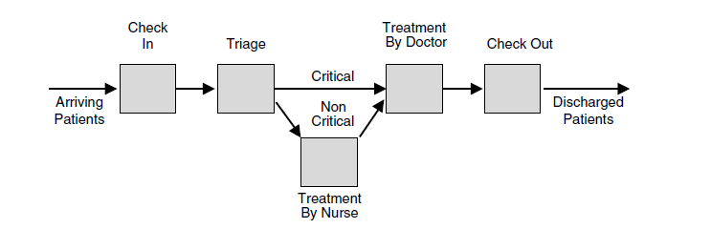
Patients arrive at the emergency room according to a Poisson process with mean Inter-arrival time of 10 minutes. An incoming patient is first checked into the emergency room by a receptionist at the reception office. Check-in time is uniform between 6 and 12 minutes. Since critically ill patients get treatment priority over noncritical ones, each patient first undergoes triage in the sense that a doctor determines the criticality level of the incoming patient in FIFO order. The triage time distribution is triangular with a minimum of 3 minutes, a maximum of 15 minutes, and a most likely value of 5 minutes. It has been observed that 40% of incoming patients arrive in critical condition, and such patients proceed directly to an adjacent treatment room, where they wait FIFO to be treated by a doctor. The treatment time of critical patients is uniform between 20 and 30 minutes. In contrast, patients deemed noncritical first wait to be called by a nurse who walks them to a treatment room some distance away. The time spent to reach the treatment room is uniform between 1 and 3 minutes and the treatment time by a nurse is uniform between 3 and 10 minutes. Once treated by a nurse, a noncritical patient waits FIFO for a doctor to approve the treatment, which takes a uniform time between 5 to 10 minutes. Recall that the queuing discipline of all patients awaiting doctor treatment is FIFO within their priority classes, that is, all patients waits FIFO for an available doctor, but critical patients are given priority over noncritical ones. Following treatment by a doctor, all patients are checked out FIFO at the reception office, which takes a uniform time between 10 and 20 minutes, following which the patients leave the emergency room.
The performance metrics of interest in this problem are as follows:
- Utilization of the emergency room staff by type (doctors, nurses, and
receptionists)
- Distribution of the number of doctors present in the emergency room
- Average waiting time of incoming patients for triage
- Average patient sojourn time in the emergency room
- Average daily throughput (patients treated per day) of the emergency room
To estimate the requisite statistics, the hospital emergency room needs to simulated for a
period of 2 days (Number of replications 5).

What is the optimum Number of Nurses, Doctors and Receptionist to minimize the waiting time in respective fields?

Practice Problems:

